ArmTracerResearchDownload User Guide

Version: 0.0.1
DocCode: SW-BASE-UG-xxx
Date: 2018-10-17



Notice
The data and information contained in this document belong to the confidentiality and property Unisoc of Zi Guang group. Unisoc reserves all relevant rights.By accepting this document, you agree that this document contains confidential information and you agree not to use or copy, in whole or in part, the document without the prior consent of unisplendour.Unisplendour reserves the right to make any changes to this document without prior notice.Unisplendour warrants that the data and information contained in this document are not, in any case, liable for any direct or indirect, any injury or loss related to the document.
Preface
Documentation
This document describes how to use the ArmTracer tool.
Reading object
This document is suitable for testers, etc.
The content is introduced
This document consists of four sections, respectively：
Chapter1: overview. The function, file composition and running environment of ArmTracer tool are introduced briefly；
Chapter2: software interface description.The ArmTracer tool interface is described and the simple operation steps are described；
Chapter3: the software parameters Settings；
Chapter4: simple and practical process；
Chapter 5: access to the software License；
Chapter 6: use guide.The usage of ArmTracer tool is described；
Chapter 7: the appendix.
The document conventions
This document USES the following bold signs to indicate areas of particular attention during the operation.
attention：
Remind the matters that should notice in operation.
instructions：
Explain the more important things.

The related documents
The Orders to record
Chapter 1 Outlines 1-1
1.1 System overview 1-1
1.2 Software installation 1-1
1.3 Operating environment 1-1
1.4 License problems 1-1
1.5 Start the software 1-1
1.6 Upgrade software 1-1
1.7 References 1-2
Chapter 2 software interface description 1
2.1 Interface description 1
2.2 Toolbar instruction 2
2.3 Status bar description 5
Chapter 3 software parameter setting 6
3.1 Set communication mode 6
3.1.1 Communication mode description 6
3.1.2 Set communication parameter 6
3.2 Set the log file to store path 7
3.3 Set the frame format of log data 8
3.4 Message decoding category setting 8
Chapter 4 simply USES process 10
4.1 Set software communication mode 10
4.2 Set communication parameter 10
4.3 Start tracking function 10
4.4 Stop tracking function 10
4.5 log file playback 10
4.6 Information query 10
4.7 Message decoding 11
4.8 Exit software 11
Chapter 5 gets the software License 12
5.1 Start ArmTracer 12
5.2 Generate authorization information feedback table 12
5.3 InstallLicense 13

Chapter 6 user guide 14
6.1 Serial port parameter setting 14
6.2 Setting of network card parameters 15
6.3 Start tracking function 16
6.4 Stop tracking function 16
6.5 Message display window overview 17
6.5.1 Click message 17
6.5.2 Window right-click menu overview 17
6.5.3 ALL message display window 18
6.5.4 DHI message display window 21
6.5.5 LAY3 message display window 21
6.5.6 Project mode message display window 22
6.5.7 LLT message display window 22
6.5.8 IPC message display window 23
6.5.9 STR message display window 23
6.5.10 FWT message display window 24
6.5.11 TAK message display window 24
6.5.12 SMC message display window 25
6.5.13 MSC message display window 25
6.5.14 WRN message display window 26
6.5.15 L1G message display window 26
6.5.16 Neighborhood message display window 27
6.5.17 SC message display window 29
6.5.18 Error blue screen information window 30
6.5.19 HFN hyperframe window 30
6.5.20 PHY message display window 31
6.6 Query window introduced 32
6.6.1 Start the query window 32
6.6.2 Query information 32
6.6.3 Query information export 32
6.7 Batch log query window introduced 33
6.8 Batch log export window introduced 34
6.9 ArmTracer interprocess message localization 34
6.10 Message decoding script editor 35
6.11 Chinese and English switching function 36

Chapter 7 Appendix 37
7.1 Appendix ARevision History 37
7.2 Software description 38

Chapter 1 overview

System overview
The ArmTracer tool software receives the running log of ARM through serial port or network card in real time, and also can decode, display, query, export and play the log in real time or playback the offline log files.

Software installation
This software can be used without installation, just uncompressing the package and run the exe.

Operating environment
This software supports windows XP/7/10. For Win7/10, run it as administrator and XP SP3 compliant.

License problems
Without a valid license, the software cannot be used properly.The license authorization information feedback table needs to be returned to generate a valid license file before the tool can be used normally.

Startup software
Double-click the armtracer.exe file in the software directory to start the software.

Upgrade software
Click the toolbar button to launch the online upgrade function.Select the version of the tool and click the button 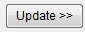 to download the specified version of the tool. It also supports rollback of previous versions.
- Instructions：

The upgrade tool can only be used in Unisoc’s OA network.

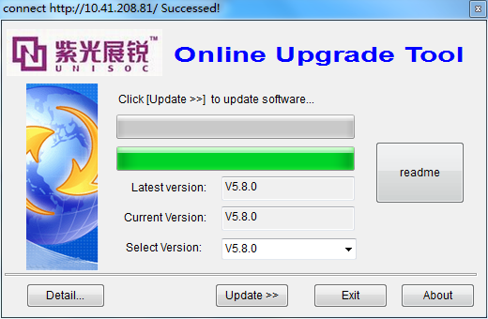
1-1 Software upgrade tool

References
Serial number | Document name | version | release date | publisher
1
2

Chapter 2 software interface description

interface description
After the software starts, each window receives the data display interface as follows: see figure 2-1, 2-2 for details.The specific tool version of the interface.
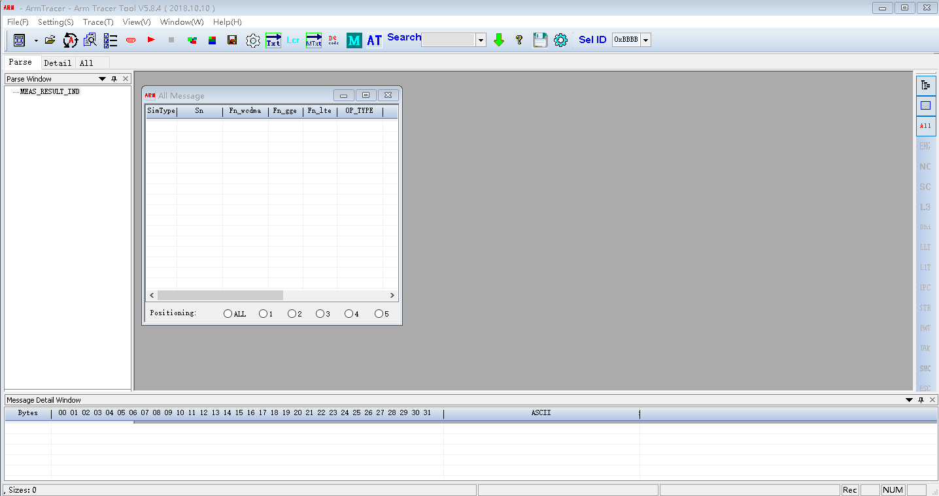
2-2 Initial software interface
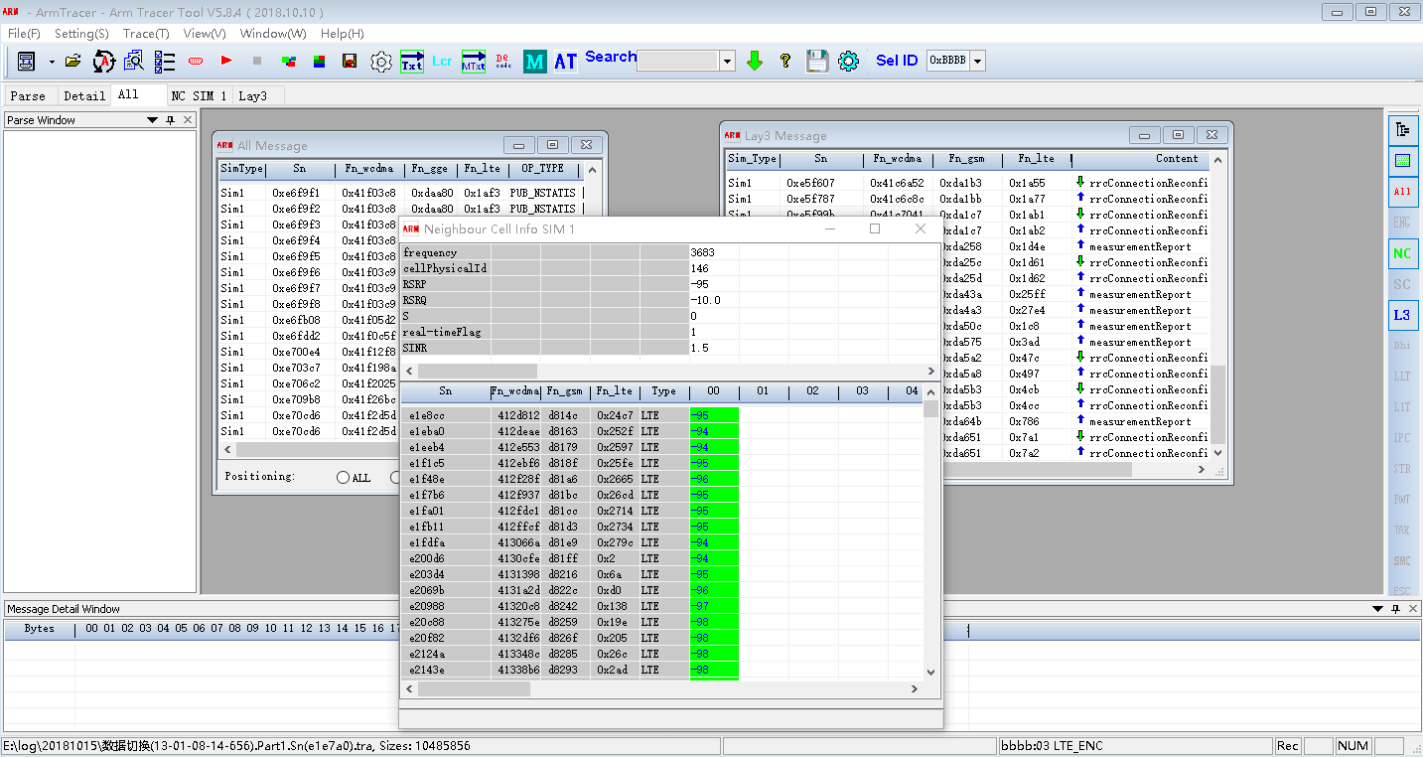
2-3 Tool main interface
Toolbar description
The tool's main toolbar is under the main menu. Under the main toolbar is the currently established subwindow list window, at the right side is the auxiliary toolbar, with the function of the subwindow list window.
2-4 The main toolbar
The main features of the tool are shown on the toolbar.
Toolbar icon | instructions
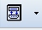 | Select communication mode.including:COM、CoolHost、PHY.  COM：Receive data from the trace serial port.  CoolHost：Receive data from CoolWatcher tool.  PHY：Receive data from the PHY test platform.
 | Open the log file for playback.
 | Multiple ArmTracer processes can be set up to locate messages between them.The default open.
 | Total query information from log files on a batch disk.
 | Message category Settings that need to be decoded
 | Serial port communication parameters or Settings with CoolHost, PHY communication port, etc
 | Enable trace function
 | Stop tracking function
 | Overlapping windows
 | Tile windows
 | Save the window layout design
 | Set the log file storage path
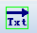 | Export query results
 | Decode the export of four TXT files
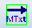 | Export the log files in the specified directory to the TXT file
 | DHI, L3 message byte stream decoding
 | Start the query window
 | Online upgrade software
 | About the software
 | Save the current log data
 | Modify the display icon of the tool in the taskbar
 | Sets the frame header flag for the log data
 | ARM and ZSP messages are displayed in separate windows

2-5 An established subwindow
This window automatically generates new windows and names these windows according to the log message data category. Double - click a window name to open the corresponding window and display.If the window is already displayed, click to hide the window, if the window is hidden, click to display the window.
2-6 Auxiliary toolbar
Auxiliary toolbar
Toolbar icon | instructions
 | Displays or hides the Tree type decoding window
 | Displays or hides the byte stream decoding window at the bottom of the software
 | Displays or hides the ALL message window
 | Show or hide the ENG information window
 | Display or hide the measurement information window of the neighborhood;
 | Show or hide the service cell message window
 | Displays or hides the Lay3 message window
 | Show or hide the Dhi message window
 | Display or hide LLT message window
 | Displays or hides the L1T message window
 | Displays or hides the IPC message window
 | Displays or hides the STR message window
 | Displays or hides the FWT message window
 | Show or hide the TAK message window
 | Show or hide the TAK message window
 | Show or hide the ESC message window
 | Display or hide MSC message window
 | Show or hide the WRN message window
 | Display or hide the L1G message window

Status bar description
2-7 The status bar
The status bar displays some status information during real-time tracking or playback. For example: current log path, received data size, communication rate and others.

Chapter 3 software parameter setting

Set communication mode
The software supports three communication modes;COM, CoolHost, PHY；Click the down arrow on the right of the toolbar and the following menu will pop up. Select the communication mode according to the actual situation.
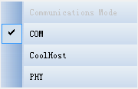
3-8 Communication mode selection

Description of communication mode
COM：Use the serial port to receive log data
CoolHost：Receive log data through the CoolWatcher tool
PHY：Receive log data through physical layer software

Set communication parameters
- If set to COM mode, click the toolbar to pop up the serial port parameter setting window. After setting the communication parameters according to the actual situation, clickto save the parameters;Clickwill not save the parameters.
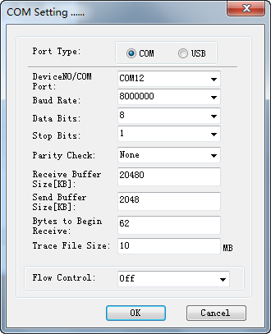
3-9 COM Communication parameter setting
- If the communication mode is set to CoolHost or PHY,network card will be used. Click the toolbar button , The following setting window will pop up.Set up the IP and port used by CoolHost, PHY and ArmTracer according to the actual situation.
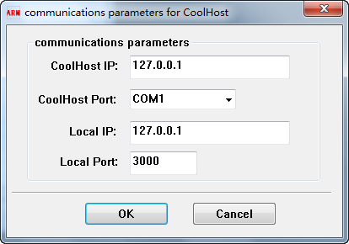
3-10 Set CoolHost and PHY mode communication parameters

Set the log file storage path
Click the toolbar button，and the log file setting window pops up, as shown in picture 3-4.Set the log storage path, file name prefix, file extension, and click the button. Click the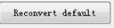 button will restore the software settings last time. Click, the software will only receive and save log data, but not decode and display log data in real time.
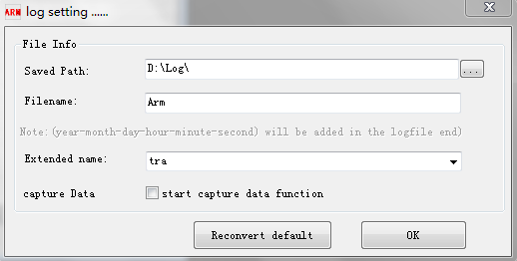
3-11 log File Settings

Set the frame format of log data

Click on the toolbar 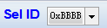,select the frame header ID of the log message: 0xBBBB or 0xCCCC.It depends on the device under test.

Message decoding category Settings
Click on the toolbar button to pop up the decoding message category setting, select the message categorys as you need.Only the selected messages could be decode, display, query, and so on.

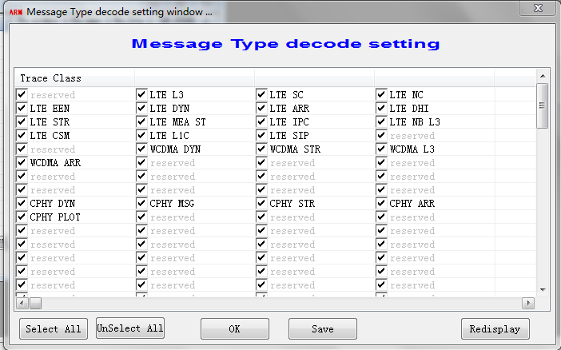
3-12 Set the message category to be decoded

Chapter 4 simply USES the process

Set software communication mode
Click on the toolbar button down arrow, pop up the setting interface, set the communication mode to receive log data.

Set communication parameters
Click the toolbar button , according to different communication modes, different settings are displayed.Set the communication parameters according to the actual situation.

Start the trace function
Click on the toolbar button. Set the log storage parameter in the pop-up window. Click OK to start the tracking function.
Ifis seleced, the tool only receives and stores log data, and does not decode and display log data in real time.

Stop tracking
Click on the toolbar button to stop tracking.

log File playback
Click on the toolbar button to select the playback log file, or directly drag the log file to the software interface, the playback of log file can be achieved.

Information query
Press Ctrl+F to start query window 1 by default.Or click on the toolbar to select the query window to start (5 query windows can be started), select the category of query, input the key word, press ENTER or click the ‘OK’ button to query the specified information.

Message decoding
Click a message in any window, such as L3 message, DHI message, IPC message, PHY message, etc., which can be decoded asn.1 or decoded by data structure, then the decoding information of the message is displayed by tree structure in the Tree window on the left of the main interface.At the same time, the original data flow information corresponding to this message is displayed in byte stream window at the bottom.
If it is a message that does not need further decoding, the original data flow information for the message is displayed in the window at the bottom of the interface.
When a message is clicked, it is positioned on the corresponding message or adjacent SN message in each window.
If two or more copies of ArmTracer are started, when you click on one message, other processes are notified and located on adjacent SN messages.

Exit the software
Press the button to exit the software.

Chapter 5 obtaining softwareLicense
Without a valid License License, the software cannot be used properly.Therefore, it is necessary to return the authorization information feedback table and generate a valid license file before the tool can be used normally.
The steps to generate the authorization information feedback table are as follows：

Run ArmTracer
Double-click armtracer.exe to start the software. If an error message window appears, regardless of it, click OK to start the software.
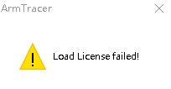

Generate the authorization information feedback table
Click on the toolbar icon ，An invalid authorization prompt appears and click ok.A feedback table output window appears.After filling in the user account name (English), the License information FeedBack form will be automatically generated by clicking the "OK" button after the start and end time of the software. The FeedBack form will be stored in the software FeedBack subdirectory.Please return the generated.fbt to generate the License information file.
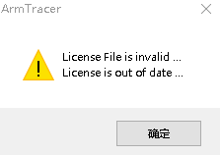

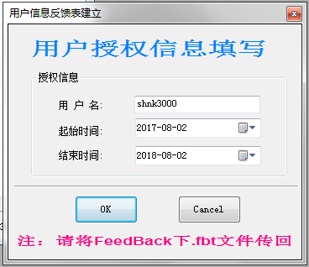
5-13 License Information generated

Installation License
Copy the valid license file into the software's DLL subdirectory, overwriting it if the file already exists.Restart the ArmTracer software, it can be used normally.

Chapter 6 Guidelines for user

Serial port parameter Settings
In COM communication mode, click the toolbar icon to start the serial port parameter setting window.
After setting according to the actual situation, click OK to save the parameters.
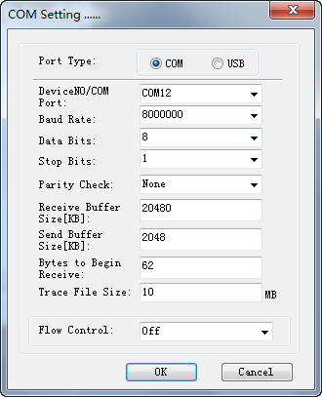
6-14 Serial port parameter setting window
Parameter Settings are described below：
- Port type：Select the port type for collecting logs. While using the driver provided by Unisoc, select the COM port. USB option is set just in case that the third-party FTDI driver been used.
- COM Port：Serial port number for log transmission.According to the actual situation.
- Baud Rate： The baud rate used for serial communication.In the software, 110--8000000 can be selected directly by default.If you do not need the baud rate, you can directly input in the display box.
- Data Bits： The data bits for communication can be set to 4, 5, 6, 7, and 8 bits.Generally 8 bits.
- Stop Bits： Stop bit of communication.1 bit, 1.5 bit, 2 bit.Generally 1 bit.
- Parity Check：Parity Settings.None: None, Odd: Odd, Even: Even, Mask: Mask, Space: empty.General to None.
- Receive Buffer Size：Buffer size Settings (in KB) for data received by the serial port.If the baud rate is high, try to set it as large as possible.For example, 10240 (10 megabytes), 20480(20 megabytes).
- Send Buffer Size： size of serial sending buffer (unit KB).
- Bytes to Begin Receive：The serial buffer begins receiving after how many bytes it receives.Generally 1 byte.
- Trace File Size：Size of each log file (in megabytes).
- Flow Control：Set the flow control mode for communication.Off: No, RTS/CTS, XON/XOFF.

Network card parameter Settings
In CoolHost and PHY communication mode, click the toolbar button to start the interface of setting network card communication parameters.Set parameters and click OK.
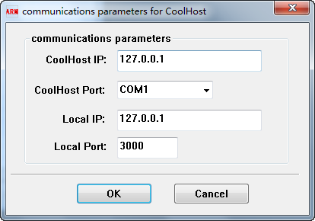
6-15 Network card communication parameter setting
parameter instructions：
CoolHost IP：Set the IP address used by CoolHost software in CoolWatcher
CoolHost Port：Set the port used by CoolHost software
Local IP：Set the IP address used by ArmTracer
Local Port：Set the port used by ArmTracer

Start tracking function
Click the toolbar icon or press F2 to start the tracking function.
Once the communication parameters are set, you can click the button to start the tracking function.When started, the log file save parameter setting window will pop up first.
The log saving path can be input in the ‘Saved Path’, or click the button to select. If the path does not exist, it will be created automatically and support multiple subdirectories.Then enter the prefix of the log file name, click to select the log file extension , or directly enter the extension name.
Click 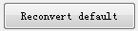 button，The path is set to the syslog subclass in the directory.
Click ‘OK’ and start tracking.
The software will save the settings automatically. The settings will be used as default value when start tracking next time.
The software, such as receipt of the log message, will automatically establishes the display window of the corresponding message, and display the decoded messaget in the window.
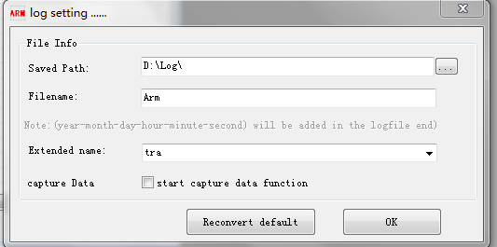

6-16 log File saving parameter Settings

Stop tracking
Click on the toolbar icon or press F3, will stop tracking function.
At this point, the software will save the tracked log data automatically.The storage path is stored as the ‘Saved Path’ in the parameter setting window of the log file, which will be stored as the name of the file name (date _ hour _ minute _ second _ hundredth second).Sn(start Sn number). Extension).
If automatic save failed, click the toolbar button to save the log data manually.

Message display window overview
Each display window are similar. Every real-time display window has a right menu. ALL message window contains the messages of all others. The same message displayed in different windows are linked to each other, while click one message in one of those windows, the other windows will show the corresponding position of this message.By clicking a message in the message windows, the decoding information of the message will display on the left and the original byte stream information will display on the bottom.

Click on the message
Click a message, and the message will display the original byte stream data in the byte stream detail window.If it is Lay3, neighborhood message, service cell message, DHI message, FWT message, IPC message, etc., the complete decoding result of the message will be sent to the left Tree message decoding window to display in the form of Tree.If Message Positioning is checked in other windows, it will be located on corresponding messages in other windows.
And for a window does not have this kind of message, some message windows have adjacent correlation.That is, if there is no corresponding message in a window, the message will be positioned on the adjacent Sn.

Overview of right-click menu
Right click menus are available in each message display window.Each window can be controlled independently.It includes control of data display column, window refresh control, message positioning control, data receiving control, memory book window setting parameters, etc.
Display column control mainly refers to the display of columns in the control window. The column name is checked and set to control the display or hiding of this column, so that users can focus on a certain column or several columns of data and shield the data information that users do not need to check.
The window refresh control mainly refers to the data refresh of the control window. The refresh button is the control button of the window refresh.When line refresh is selected, the tool automatically checks the refresh and cancels page refresh. The window will refresh the data row by row.Line refresh will display the received data in real time, but it consumes a lot of CPU resources.When page refresh is selected, it will check the refresh and cancel line refresh.When the window receives the specified number of message records, it will refresh the window. The window does not need real-time refresh, which reduces CPU consumption.However, it is not convenient for users to view messages in real time.CPU consumption is minimal without refresh.Users can choose different refresh methods according to actual needs.
Message positioning control. When you click a message, you can locate the corresponding message between the query window and other windows that allow message positioning.If it’s not selected, other windows will not locate the message when clicking the message.
Data receiving control controls whether the window receives, decodes and displays data, and does not affect the data receiving of other windows.
Even if all windows stop receiving data, the software still receives and stores the log data in the background. This function will work while ‘start capture data function’ is selected when you start tracking.
Save window settings parameters. When user starts the tool next time, it is unnecessary to set the window parameters again.

ALL message display window
When the ARMTracer tool starts, the ALL message window will start automatically.When the ALL message window displayed, clicking the icon will hide this window.Clicking again will display it.The window displays as shown in figure 6-4.
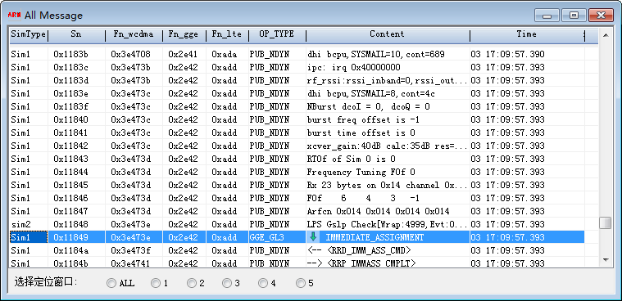
6-17 ALL message display window
Click the right mouse button in the ALL message window to pop up as shown in figure 6-5. The corresponding list parameters and function setting options in the ALL message window will be displayed in this menu.
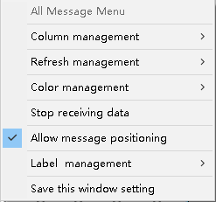

6-18 ALL window right-click menu
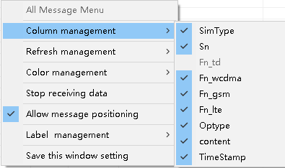

6-19 Display column control menu

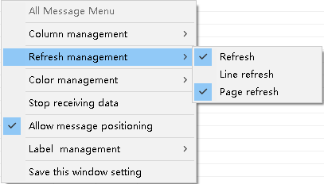

6-20 Window refresh control menu
You can see the ALL window data display column, which is described as follows：
- Sn：Message number
- Fn_td：TD frame number
- Fn_GSM：GSM frame number
- Fn_lte：LTE frame number
- OP_TYPE：message category
- Content：The decoded content of the message
Displays the settings of the data column in the window.Selected, then show, if not, then hide.
For winows refresh management, the refresh control must be turned on first.When ‘Refresh’ is not selected, the window will not refresh.If the refresh function has been turned on, select ‘line refresh’, the window will refresh row by row and ‘Page refresh’ will be invalid. While Selecting to ‘Page refresh’ the window will refresh when the received data reaches the specified number of records per page and ‘Line refresh’ will be invalid.
Select different refresh methods, the system resources and processing speed are completely different. Do not open refresh, the software processing speed is the fastest, the system resource consumption is the least.
Line refresh: the window will refresh when every message received.The software data processing speed is the slowest, system resource consumption is the largest.
Page refresh: after receiving the specified number of messages, the window will be refreshed.This setting, software processing speed, system resource consumption is moderate.
Stop receiving data: this option is in ALL message right-click menu, while it’s selected the window will no longer receive, decode, or display log messages.But the software is still receiving data in the background, unless you click the icon on the toolbar or press F3 to stop tracking.If the log data is too large to display in real time, you can use this mode to receive the log first, and then play back for analysis.
Allow message positioning: this option is in ALL message right-click menu, while it’s selected, a message can be located between the query window and other windows that allow message positioning to a corresponding message.

DHI message display window
When the DHI class log data is received, the software creates the DHI message window dynamically.When a DHI message window displayed in the tool, click the icon will hide the window.When the DHI message window is hidden, click the toolbar icon to display the DHI message window.The window displays as shown in figure 6-8。
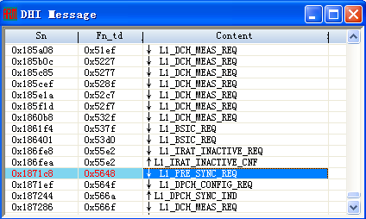
6-21 DHI message window
The DHI message window also has a right-click menu that functions similar to the ALL message window.

LAY3 message display window
When the L3 class log data is received, the software will create the Lay3 message window dynamically. When the Lay3 message window displayed in the tool, click the icon to hide the window.When the Lay3 message window is hidden, click the toolbar icon to display the Lay3 message window.The window displays as shown in figure 6-9.
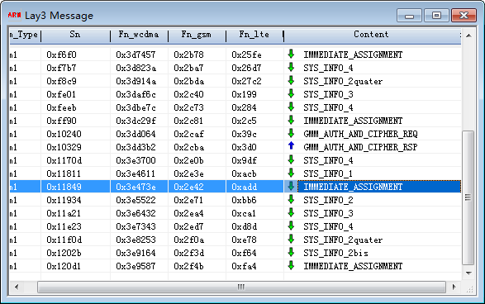
6-22 Lay3 message display window
Lay3 message window also has a right-click menu, similar to the ALL message window.

Project mode message display window
When ENG engineering mode class data is received, the software creates the engineering mode message window dynamically, and the window always displays at the top of the screen.When the message window displayed in the tool, click the icon will hide the window.When the message window is hidden, click the toolbar icon to display the message window.
6-23 Engineering mode window

LLT message display window
When the log data of LLT class is received, the software will create the LLT message window dynamically. When the message window displayed in the tool, click the icon will hide the window.When the message window is hidden, click the toolbar icon to display the message window.The window displays as shown in figure 6-11.
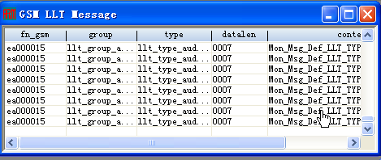
6-24 LLT window
The LLT message window also has a right-click menu, similar to the ALL message window.

IPC message display window
When the IPC class log data is received, the software will create the IPC message window dynamically, and when the message window displayed in the tool, clicking the icon will hide the window.When the message window is hidden, click the toolbar icon to display the message window.A window displays as shown in figure 6-12.
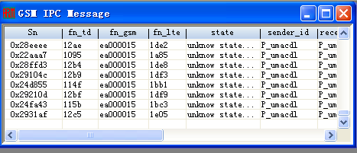
6-25 IPC window
The IPC message window also has a right-click menu, similar to the ALL message window.

STR message display window
When the STR class log data is received, the software will dynamically create the STR message window. When the message window displayed in the tool, click the icon will hide the window.When the message window is hidden, click the toolbar icon to display the message window window. The window displays as shown in figure 6-13.
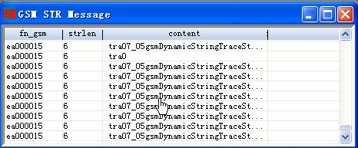
6-26 STR String window
STR message window also has a right-click menu, similar to the ALL message window.

FWT message display window
When the FWT data is received, the software will create the FWT message window dynamically. When the message window displayed in the tool, click the icon to hide the window.When the message window is hidden, click the toolbar icon to display the message window.The window displays as shown in figure 6-14.
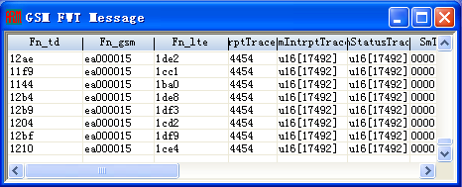
6-27 FWT window
FWT message window also has a right-click menu, similar to the ALL message window.

TAK message display window
When the TAK class log data is received, the software will create the TAK message window dynamically, and when the message window displayed in the tool, click the icon will hide the window.When the message window is hidden, click the toolbar icon to display the message window. The window displays as shown in figure 6-15.
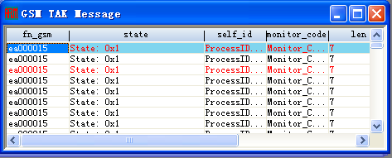
6-28 GSM TAK Task window
TAK message window also has a right-click menu, similar to the ALL message window.

SMC message display window
When the SMC class log data is received, the software will create the SMC message window dynamically, and when the message window displayed in the tool, click the icon will hide the window.When the message window is hidden, click the toolbar icon to display the message window.Window display as:
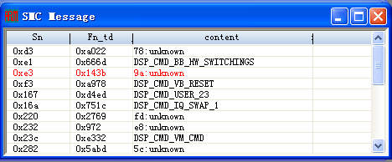
6-29 SMC Message window
SMC message window also has a right-click menu, similar to the ALL message window.

MSC message display window
When the MSC and IPC class log data are received, the software will create the MSC message window dynamically. When the message window displayed in the tool, click the icon to hide the window.When the message window is hidden, click the toolbar icon to display the message window.The window displays as shown in figure 6-17.
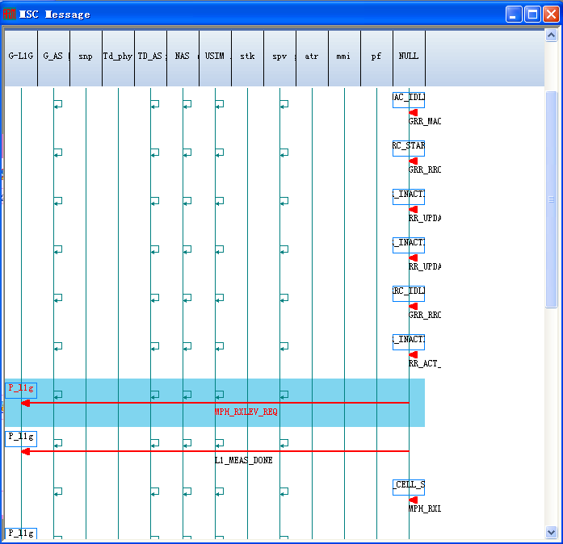
6-30 MSC window

WRN message display window
When the log data of the WRN class is received, the software will create the WRN message window dynamically. When the message window displayed in the tool, the icon will hide the window.When the message window is hidden, click the toolbar icon to display the message window.The window displays as shown in figure 6-18.
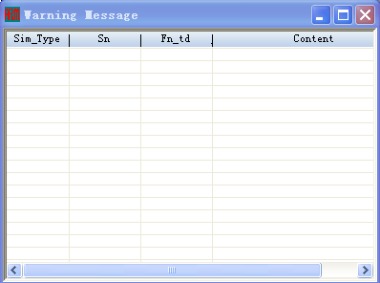
6-31 WRN Message window

L1G message display window
When the L1G class log data is received, the software will create the L1G message window dynamically. When the message window displayed in the tool, click the icon to hide the window.When the message window is hidden, click the toolbar icon to display the message window.The window displays as shown in figure 6-19.
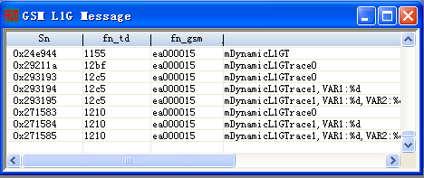
6-32 GSM L1G window

L1G message window also has a right-click menu, similar to the ALL message window.

Display window of neighborhood information
When receiving the log data of measurement class in neighboring cell, the software will dynamically create the NC window of neighboring cell message. When the message window displayed in the tool, click the icon to hide the window.When the message window is hidden, click the toolbar icon to display the message window.The window displays as shown in figure 6-20.
The neighborhood window consists of three parts, and the specific window interface is shown in figure 6-20.
In all measurement message windows, the same frequency in the last message are displayed in the same column.The first frequency of each message is shown in green.The frequency in a message which is not in the previous message is shown in gray.
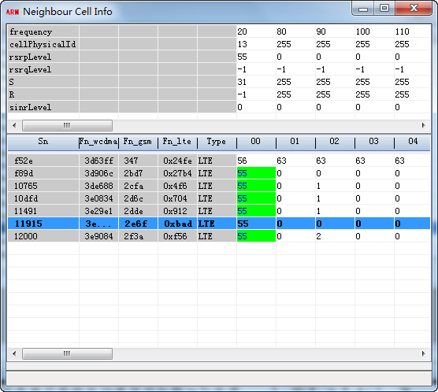
6-33 Neighborhood measurement message window

Top window: current measurement message display window.If you click on a measurement message in the middle window, the information of a measurement message is displayed.
Middle window: all measurement message display windows.Displays information of up to 40 frequency points, which is automatically overwritten from left to right after exceedin.
Bottom window: the full information display window of a measurement message.
In all measurement message windows, the same frequency points in the last message are displayed in the same column.The first frequency point of each message is shown in green.The frequency points in a message that are not in the previous message are shown in gray.
Right-click anywhere in all measurement information windows, and the right menu will pop up as shown in figure 6-21 , neighborhood Right-click menu.
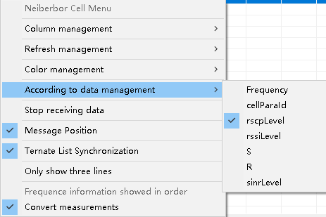
6-34 neighborhood Right-click menu
The common control function of the right-click menu is basically the same. If user select ‘Ternate List Synchronization’, all three windows will roll at the same time when drag the slider.If it’s not selected,only the top and middle windows will roll at the same time when drag the slider.
If ‘Only show three lines’ is selected, the current measuring message window displays only the top three rows of parameters.If it’s not selected, all seven lines parameters will be displayed.
Which patameter to show in the measurement message display windows can be set through ‘According to data management’. User can choose one of the measurement parameters including Frequency、cellParaId、rscpLevel、rssiLevel、S、R、sinrLevel to display in the windows as needed.

SC message display window
When SC class log data is received, the software will create SC message window (service cell window) dynamically, and when the message window displayed in the tool, click the icon will hide the window.When the message window is hidden, click the toolbar icon to display the message window.The window displays as shown in figure 6-22.

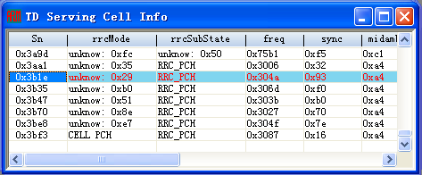
6-35 Service cell window
The SC message window also has a right-click menu, similar to ALL message window.

Error information window
After receiving the assert class log information, the software automatically creates an Error window to display the assert information. As shown in figure 6-23.
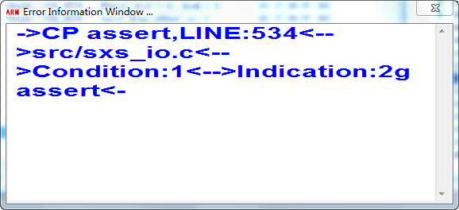
6-36 Error information window

HFN Superframe window
When the software receives the log data of the hyperframe number, it will create the HFN window dynamically and display the hyperframe number.As shown in figure 6 – 24.
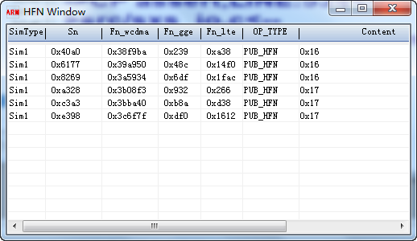
6-37 Superframe window

PHY Message display window
The software receives the physical layer PHY class log data and sets up the PHY window dynamically.As shown in figure 6-25.Click a message to display the decoding of the message data structure in the Tree window.
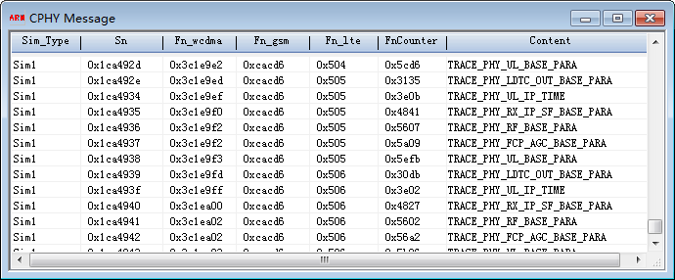
6-38 PHY Message display window

Query window

Start the query window
Press Ctrl+F on ALL window to start query window 1 by default, or click the toolbar button to select the query window (5 query windows can be choosen).As shown in figure 6-26.
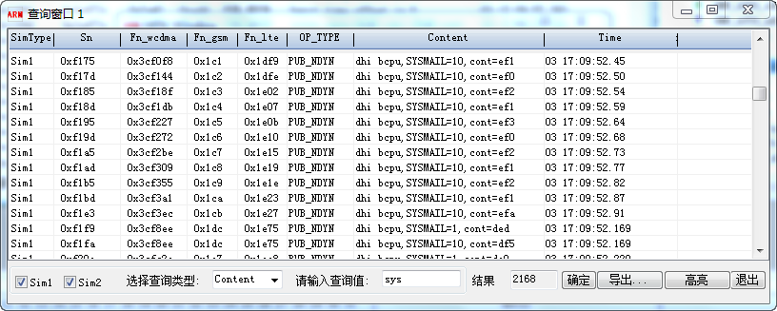
6-39 Information query window

Query information input
Select the query type (default value is Content) from here, input the key word, press enter or click the ‘OK’ button to query the messages.

Query information export
Click the button in the query window and the export window will pop up as shown in figure 6-27. The query results are exported in Excel's.csv format. Click, the export file will be named by the key word；
Click will export all displayed information of the current log file.
If not select 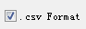, the export file format is text.
If user input the SN range, the export file will contain the messages within the specified SN range only.
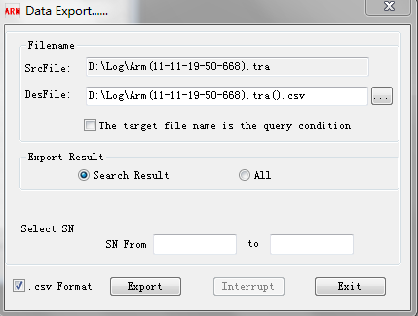
6-40 Query result export

Batch log query window introduction
Click the button on the software toolbar to start the batch log query function，and the window as shown in figure 6-28 pops up。The window queries the specified information directly from a set of log files in the specified directory.The way to use is similar to charpter 6.6.
‘Consume less CPU resource’ is selected by default, if you want the query to be faster, please disable this option.
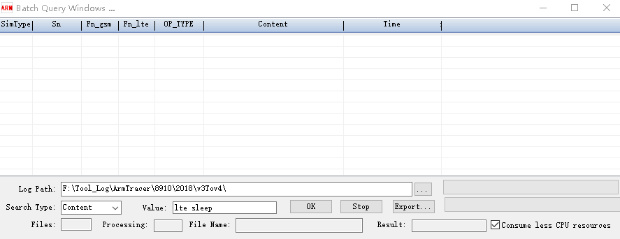
6-41 Batch log query window

Batch log export window introduction
Click the toolbar 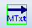 button to start the batch export function. As shown in figure 6-29.This function converts all log files in the specified directory into text files.
Select the storage path of the source log file and the storage path of the exported text file, and click the export button to start the export.
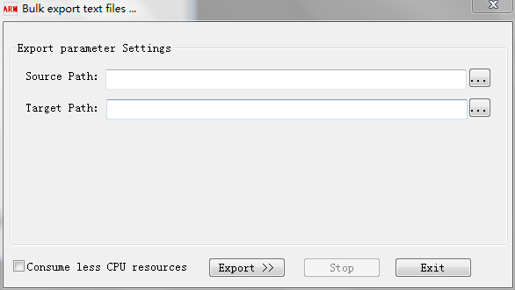
6-42 Batch log file export

ArmTracer Interprocess message location capability
If two or more copies of the ArmTracer software are running, click a message in one ArmTracer will locate an adjacent SN message in another ArmTracer.If you don't need this feature, you can disable it.
Click the toolbar button and the window as shown in figure 6-30 will pop up.Click OK after setting.
：Allows this ArmTracer to send location information to other ArmTracer.
：Allows this ArmTracer to receive location information for other ArmTracer.
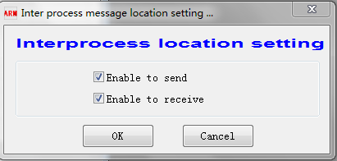
6-43 ArmTracer Interprocess message localization Settings

message decoding script editing
Click the edit DAT file function in the system menu, pop up the DAT file selection window. Double-click a file, the operating system's default text edit tool will open it. After editing the file, save it and restart the Armtracer.
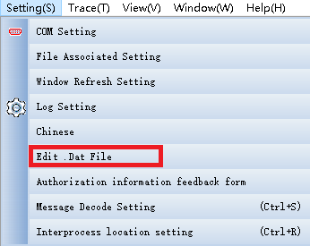
6-44 Software system Settings menu

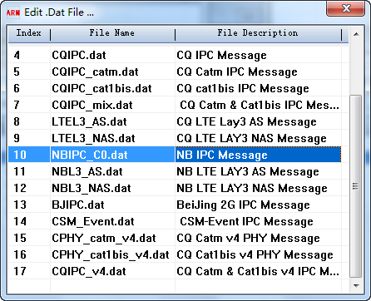
6-45 Message script list window

Language
The software only supports Chinese or English display.Click the English menu item under the system menu, and the software will switch to the English interface.Click the Chinese menu item under setting menu and switch to the Chinese interface.
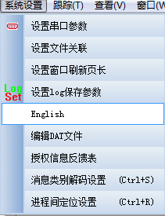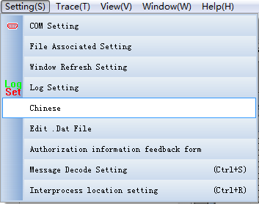
6-46 Software system menu

Chapter 7 Appendix

Revision History
Version | Date | Owner | Notes
0.0.1 | 2018-09-06 | Hongyun Tan | Set up the document

software description
The features of each software version may not be consistent with this guide.Some features have been modified, and some have not been described.The specific functions are related to the software version.

